**Assignment 17.5**

Write a map reduce program to desing a custom counter to count number of people are affected with 'PULMONARY' disease and 'BRONCHITIS & ASTHMA' in the state 'CA'.

The dataset description is as follows DRG Definition: varchar Provider Id :integer Provider Name :varchar Provider Street Address : varchar Provider City : varchar Provider State : varchar Provider Zip Code : integer Hospital Referral Region Description : varchar Total Discharges : integer Average Covered Charges : float Average Total Payments : float Average Medicare Payments : float

**Driver Class**

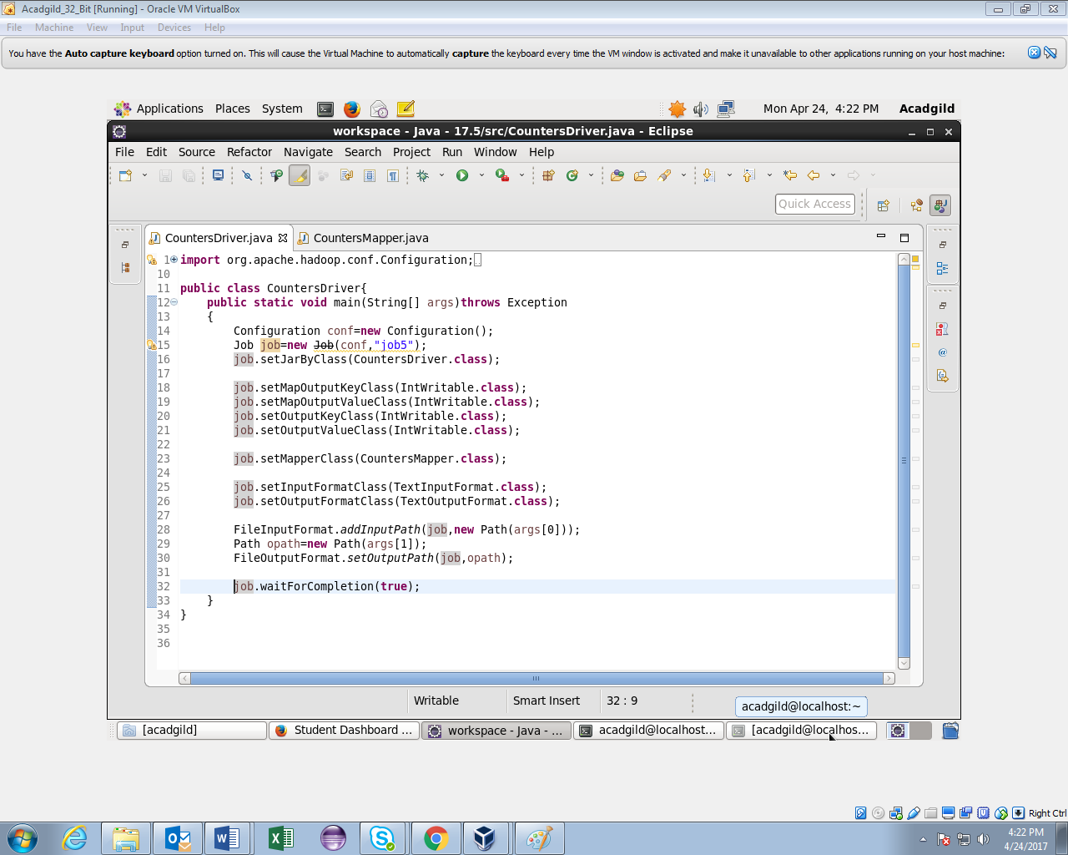

In this example we will just create the Map only job, we are concentrating only on implementation of counters

Counters are defined by a Java enum, which serves to group related counters.

Step 1: Create the ENUM for counters.

Since we are counting 2 types of diagnosis ENUM will become the group and fields will become the counters.

Step 2: Find the counters in Mapper and increase the counter

By using the above use case we have got the details of all the types of counters discussed and refer the below screen shot for the same:

**Mapper Class**

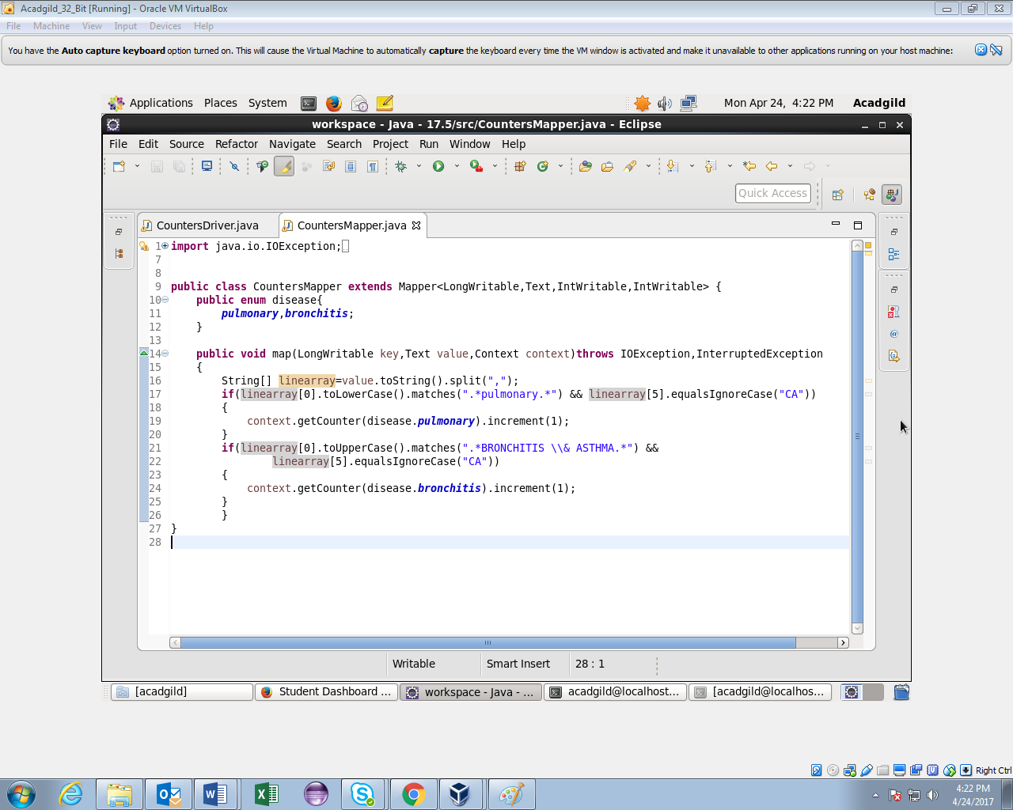

By using the above use case we have got the details of all the types of counters discussed and refer the below screen shot for the same:

**Running jar**

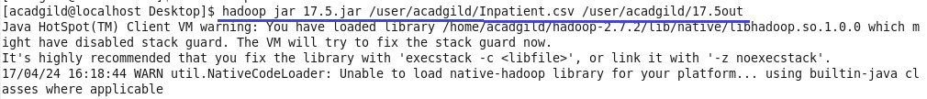

**Output**

